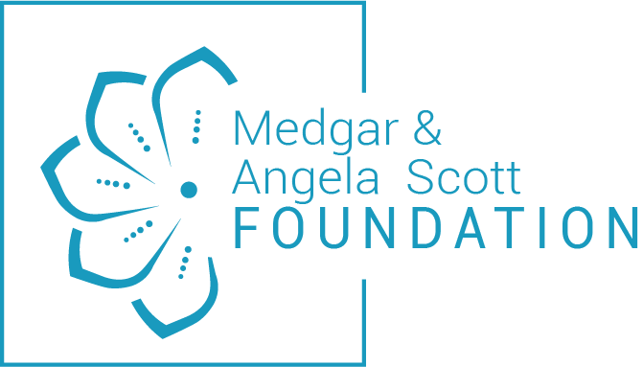

2026 Scholarship Program Application

Hello Graduating Senior!
Congratulations on the culmination of twelve years of hard work and academic development. You have indeed reached a milestone in your life, and the best is yet to come. As you move forward to further your education, the Medgar and Angela Scott Foundation would like to assist you. This scholarship aims to provide students with an opportunity to further their education in a world of growing costs and challenges. Our organization is dedicated to helping young men and women advance their education.
We are announcing our 2026 Scholarship Program. We will award four (4) scholarships totaling $15,000 to outstanding students in the Vicksburg area.
- Medgar Scott Memorial Scholarship $5,000 award to a male student
- Angela Scott STEM Scholarship $5,000 award to a female STEM student
- Medgar and Angela Scott Scholarship $2,500 award each to two students
The criteria for eligibility of our scholarship program:
- A graduating senior planning to pursue a bachelor degree and has been accepted to a four-year college/university
- Copy of Acceptance letter from College/University
- Cumulative GPA of 2.5 or above on a 4.0 scale shown on a transcript from the applicant’s school. (A scanned copy is sufficient)
- Copy of ACT and/or SAT scores
- Demonstrated involvement in applicant’s school activities and community
- Two letters of recommendations:
  - One (1) from one of the applicant’s teachers or school counselor
  - One (1) from someone that has known the applicant while he or she attended high school but is not a relative, i.e., a neighbor, church member, friend of your parents
- Submission of a 500-word essay (see page 4 for instructions)
- Attach a color photograph (jpeg print quality headshot)
- COMPLETED PACKET MUST BE RECEIVED BY May 27, 2026
- Email completed packet to angela.scott@masfvicksburg.org
SCHOLARSHIP APPLICATION FORM
Name |  |  | DOB (mm/dd/yyyy)
Address
Home Phone (include area code) | E-Mail
Parent(s) Name

High School |  |  | Cumulative GPA
College or University planning to attend |  | Intended Area of Study (Major)
COMMUNITY/EXTRACURRICULAR ACTIVITIES
Name of Event/Activity |  |  |  | Date(s) of Involvement
Description

Name of Event/Activity |  |  |  | Date(s) of Involvement
Description

By completing and signing this application, I affirm that I meet the eligibility requirements and would like to be considered. I acknowledge that my name and picture will be on the website.

Student Signature: ______________________________________________ Date: ___________

Parent or Guardian Signature: _____________________________________ Date: ___________

ESSAY
Compose an essay of 500 words on one of the topics below. Essays must be typed, double spaced, in 12-point font with one-inch margins on all sides.
Topics
- Discuss the specific character strengths you possess that will help you succeed in college and life. Discuss your weaknesses and how you intend to develop and overcome them so they don’t hinder your success.
- Describe examples of your leadership experience in which you significantly influenced others, helped resolve disputes, or contributed to group efforts over time. Consider responsibilities to initiatives taken in or out of school.
- What is the importance of civic and social engagement to help your community change and thrive?

CHECKLIST
To ensure you include all the required materials, review the checklist below prior to submitting your packet.
- Completed application
- 500-word essay
- Two (2) letters of recommendation
- Copy of Official Transcript from the applicant’s school
- Copy of College/University acceptance letter (can be provided at a later date)
- Copy of SAT/ACT scores
- Color photo
- Submit completed application packet to: angela.scott@masfvicksburg.org

THE PACKET MUST BE RECEIVED BY May 27, 2026.
Scholarship winners will be announced June 29, 2026 .
Questions?? Contact Angela Scott at (770)845-9772, angela.scott@masfvicksburg.org

